WORK-CASE №7

***Виконали студенти Коваленко С. та Корольов Є.***

1. В ході роботи досить часто виникає завдання планування задач:

- Охарактеризуйте основні функції які може виконувати планувальник завдань в будь-якій ОС. Порівняйте можливості планування завдань в різних ОС на прикладі Windows та Linux.

The Task Scheduler is a system tool that allows you to automate the execution of tasks at a specified time or under certain conditions.

The main functions of the task scheduler include:

* Automation of task execution: Ensures that programs, scripts or commands are executed at a specified time or after a specific event.
* Flexibility in setting the execution time: Tasks can be run periodically (daily, hourly, daily, minutely) or at a single time.
* Interaction with system events: Respond to system events such as user logins, system startup, or triggers.
* Monitoring and logging: Maintain logs to record completed tasks, detect errors, and monitor the success of the execution.
* Task prioritisation: Allows you to set up a queue of tasks based on their importance.
* Multi-user support: Ability to run tasks on behalf of different users using their accounts.

**Task Scheduler in Windows**

Windows uses the Task Scheduler tool to automate the execution of tasks.

Features:

* Intuitive graphical interface for setting up tasks.
* Supports running programs, scripts, and commands at specified intervals.
* Ability to create tasks that are triggered by system events (for example, user login or system startup).
* Logging of completed tasks in the Event Viewer.
* Support for running tasks with administrator or other user rights.
* Example of use: Create a task to run a script daily at 12:00:
* Open Task Scheduler.
* Create a new task.
* Specify the trigger (daily) and action (script execution).

**Task scheduler in Linux**

In Linux, the main tools for scheduling tasks are cron (for regular tasks) and at (for one-time tasks).

Features:

*cron:*

* Suitable for periodic tasks.
* Tasks are configured in the crontab file.
* It is used to automate system maintenance (e.g., backups, clearing logs).

*at:*

* Allows you to run a task once in the future.
* Simple text-based command-line interface.
* Support for logs via the system log (/var/log).
* Flexibility due to the ability to execute any commands or scripts.

- Опишіть основні принципи роботи з планувальником Cron в ОС Linux. Як його налаштовувати? Чи є йому альтернативи (дайте їх характеристику).

***Виконав студент Горохов Данило.***

2. Для вашої віртуальної машини зі встановленою ОС Linux здійсніть планування обраних вами задач (запуск додатків, вмикання/вимикання машини, очистка каталогів, видалення файлів, резервне копіювання, архівування тощо на ваш вибір) через планувальник Cron:  
- Виконання спланованої задачі в чітко визначений Вами час (наприклад о 8 ранку, 18.30 і т.д.).  
- Виконання однієї й тієї ж задачі двічі в день (час також визначаєте самостійно).  
- Виконання однієї й тієї ж задачі тільки в будні (або тільки у вихідні дні) у чітко визначений проміжок часу (наприклад з 8 до 18 години).  
- Виконання задач тільки раз у рік, раз у місяць, раз у день, щогодини, при вмиканні (після перезавантаження).

I don't have Cron installed on my virtual machine, so to install it, I need to write the command:



To get started with Cron, you need to write the command:



And choose the editor where we will write the planned tasks (I chose the one that is offered by default by Linux - the GNU Nano editor.

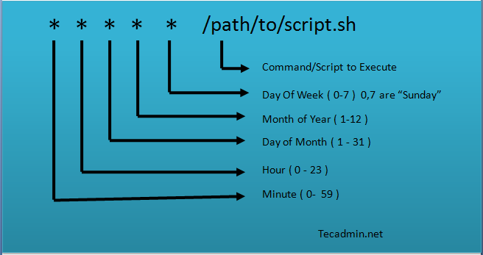Cron Recording Format:

Executing the planned task at a clearly defined time (as a task – I chose to clean up the temporary /tmp folder at 08:00 in the morning:



Performing the same task twice a day (e.g. run the backup script /home/user/backup.sh at 09:00 and 21:00):



Performing the same task only on weekdays in a clearly defined period of time (for example, run the resource monitoring script /home/user/monitor.sh every hour from 08:00 to 18:00 on weekdays):



Performing a task once a year (e.g. system update on January 1, 05:00):



Performing the task once a month (delete old displayed messages (logs) every 1st day of the month at 02:00):



Perform the task once a day (check the disk status at 03:00):



Executing the task every hour (updating the database every hour):



On reboot (run the initialization script):



To exit the terminal, ctrl+x;

Instead of user, you need to specify the current username of the user, in my case danilmint.

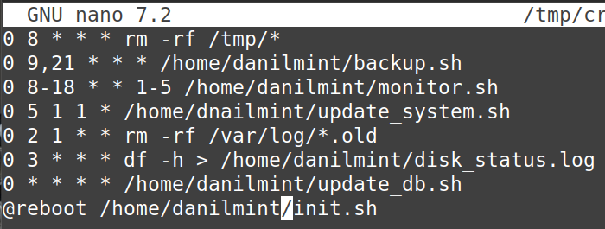

See the list of tasks:

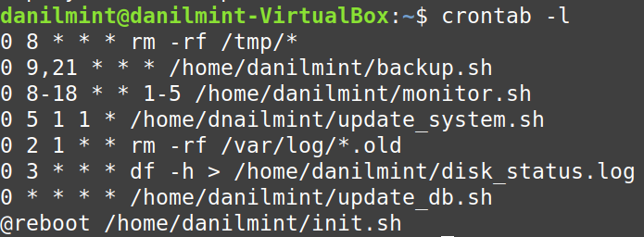

The scripts I mentioned above are not valid, so they need to be created and edited to suit our needs. To do this, use the commands: touch file.sh and

chmod +x file.sh. Then select the editor and edit the nano file.sh in it

3. Встановіть альтернативний Cron’у планувальник задач (на Ваш вибір). Виконані у завданні 2 дії продемонструйте через нього.

As an alternative to cron, I decided to install systemd timers. It is already integrated into most modern distributions. You can run a check to make sure:

To complete tasks, you need to create a timer and then perform actions with it.

To do this:

Go to the directory to configure services and create a service file for the task (the name can be any):



Adding content:

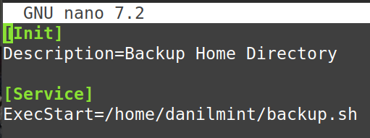

Creating a timer file:



Adding content:

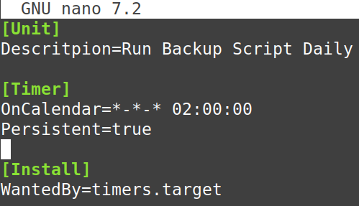

Restart systemctl to apply the changes:



Turn off the timer, then start, check the status:



We get a timer:

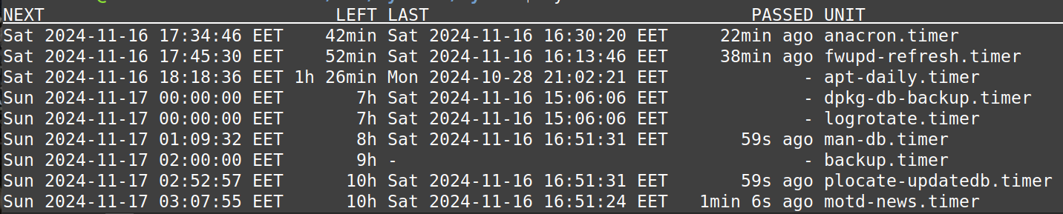

Run the script twice a day:

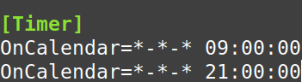

Launch only on weekdays:



Launch once a year:



Starting when overloaded:

